Kickstarter Analysis Report

Ronjini Hassan

1. 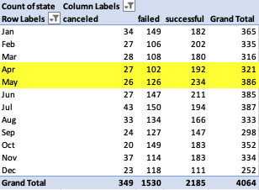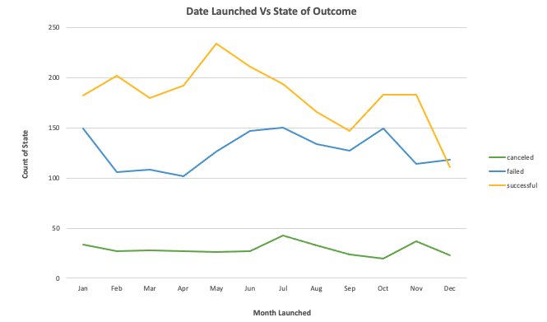**Given the provided data, what are three conclusions we can draw about Kickstarter campaigns?**
2. 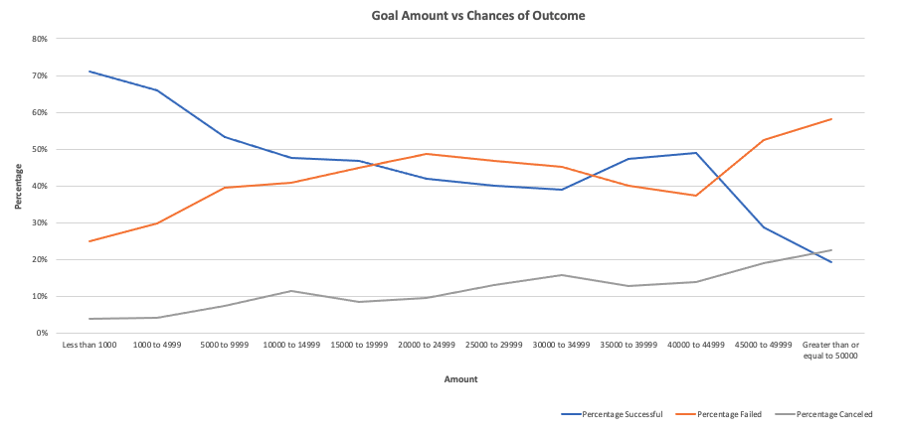According to the pivot table line chart referencing the date launched versus the state of the outcome, we can infer that the best time to launch a campaign is between April and May. The majority of campaigns launched during these months were successful with a rate of about 60% compared to the total number of projects.
3. Campaigns with lower initial goals are more likely to succeed. Once the goal amount increases above $1000, the chances of success continue to decline. While it seems obvious that smaller funding goals would be easier to achieve, it might deter other new start-ups to set higher goals. Interestingly, however, we see a small increase in success rate between $30,000-$45,000. It would be insightful to see if that is an outlier, specific to a certain country or parent category/sub-category.

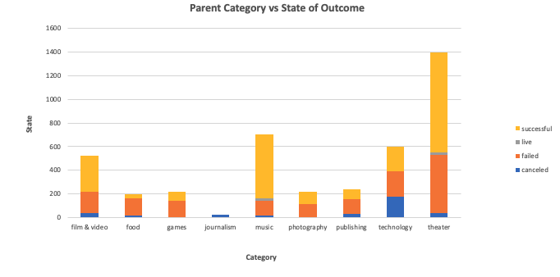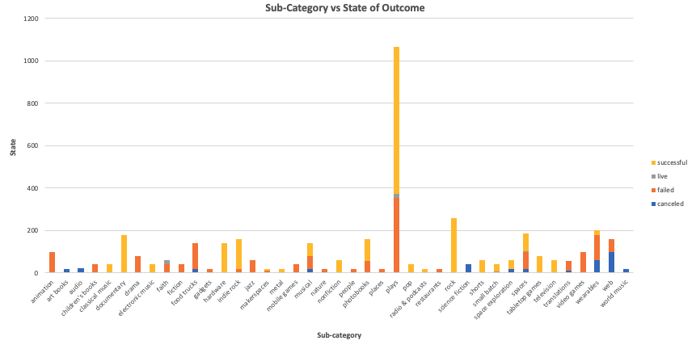

1. Theater, music, and film/video are the most popular campaigns categories on Kickstarter and seem to have the highest number of successful projects. Within those parent categories, “plays” drastically skew those results with the highest number of campaigns - the majority being successful, but also a significant number of failed projects. Music also shows great success on Kickstarter, with sub-category “rock” specifically showing an impressive success rate (no failed or cancelled projects) within this data set.
2. **What are some limitations of this dataset?**

The dataset is limited to Kickstarter. There are many other crowdfunding sources such as Indiegogo, GoFundMe, Patreon, etc. so we cannot assume that Kickstarter paints the whole picture of discovering tips for success.

The dataset is also not large enough and inclusive of all categories and subcategories, showing only for 21 countries between 2009-2017. While these countries may represent a large number of projects on their platform, there are thousands that are not represented that can skew an organization’s understanding of the data.

The dataset also does not define what it means for a project to be “successful.” For most start-ups, the goal is to be profitable long-term. In this case, we can assume it means that the campaign achieved or surpassed their initial goal. However, how many of these “successful” campaigns went on to become profitable and/or are still running present-day?

**3. What are some other possible tables and/or graphs that we could create?**

We could create a pivot table that compares the parent-category (or sub-category) with the initial goal. This could provide some insights into how much money certain types of projects need and how that correlates to their outcome. From this table, a scatter plot for each parent-category could help visualize what that relationship looks like.

We could also use a box plot for the number of successful campaigns/backer count and unsuccessful campaigns/campaign backers to visualize the variability of the two.